Ref. No. JSSA/LC/02202933
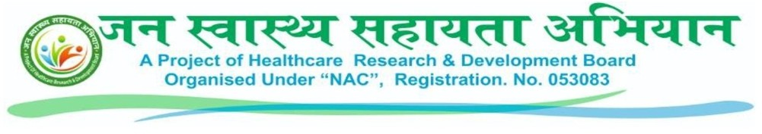
Letter of Consent
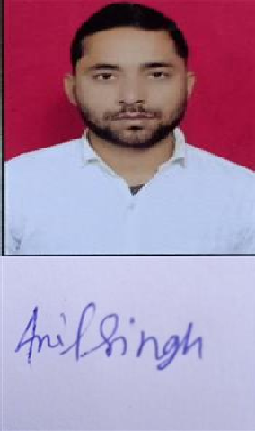
This consent letter is being done on 11/17/2025 2:19:20 PM between JAN SWASTHYA SAHAYATA ABHIYAN (A project of Healthcare Research and Development Board organized under NAC which is registered under companies act 2013 (section 8) Reg.No:053083) and selected DISTRICT MANAGER ANIL SINGH JADAUN S/O(D/O) -NAVAL SINGH JADAUN Under JAN SWASTHYA SAHAYATA ABHIYAN with the following conditions.

- Selection is being done by the social service organization NAC (which is registered under the Companies Act 2013 (section 8)) under JAN SWASTHYA SAHAYATA ABHIYAN against the post of DISTRICT MANAGER

- Facilities given to permanent employees will not be admissible as DISTRICT MANAGER

- Selection will be purely on contract basis and neither the permanent employee of the organization nor the organization will be entitled for regularization in the service.

- This selection will be for a probationary period of 3 months from the date of appointment. On expiry of the probationary period it is open for the management either to confirm your services or extend your probationary period. Such an extension can be granted for a maximum of 11 months more, The Management, however, reserves the right to terminate your services without assigning any reason during the probationary period, or the extended probationary period. However during the probation period, services can be discontinued without any notice.

- Legal action will be taken by terminating the service at any time after giving a notice to the selection received on the basis of wrong facts and papers.

- I have not committed a cognizable offense and have not been imprisoned in any case.

- selection may be terminated at any time as per the requirement or as decided by the Director of the organization.

- verification of wrong documents given by me, legal action will be taken against me and I will not be entitled for honorarium and incentive.

- The service of the selected DISTRICT EXECUTIVE is not satisfactory and does not follow the discipline, he will be terminated from service at any time by giving a notice.

- Guidance and guidelines issued from time to time in JAN SWASTHYA SAHAYATA ABHIYAN will be effective.

- For each month a certain target will be given by the organization, my selection may be terminated if the target is not met.

- I will be given honorarium and incentive for my service under the JAN SWASTHYA SAHAYATA ABHIYAN guideline. Apart from this, I will not make any claim of any kind.


- I will be paid honorarium according to the monthly target by the organization, if I do not full fill the target given by the organization, then I will not be entitled to honorarium and any kind of benefit.

- leaving the district, I will inform the concerned officer and action can be taken against me in absence without notice.

- I will be regularly present in the review to be done by the JAN SWASTHYA SAHAYATA ABHIYAN or senior officer of the organization and action can be taken against me for giving any wrong information.

- In the case of any complaint to the citizen of my jurisdiction or the senior officer of the organization, the organization has full rights, they can take legal action against me at their discretion.

- I will be present in all the training and meeting as prescribed by the JAN SWASTHYA SAHAYATA ABHIYAN and senior officer of the organization.

18.I will not charge any extra fee from any other organization and person other than the prescribed fee of the institution for the works prescribed in the JAN SWASTHYA SAHAYATA ABHIYAN, if I work against it, then the organization has full right to take action against me.

- This organization is a social service organization that works through contributions and donations, so the application fee, training fee and other expenses fees given by me as a contribution will not be refundable. I am not entitled to take this fee back from the organization.

- I have applied on my own free will and full discretion to work on the post of DISTRICT Manager in the organization, no pressure has been put on me for this.
Received By
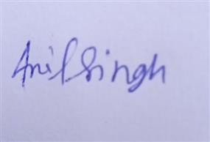
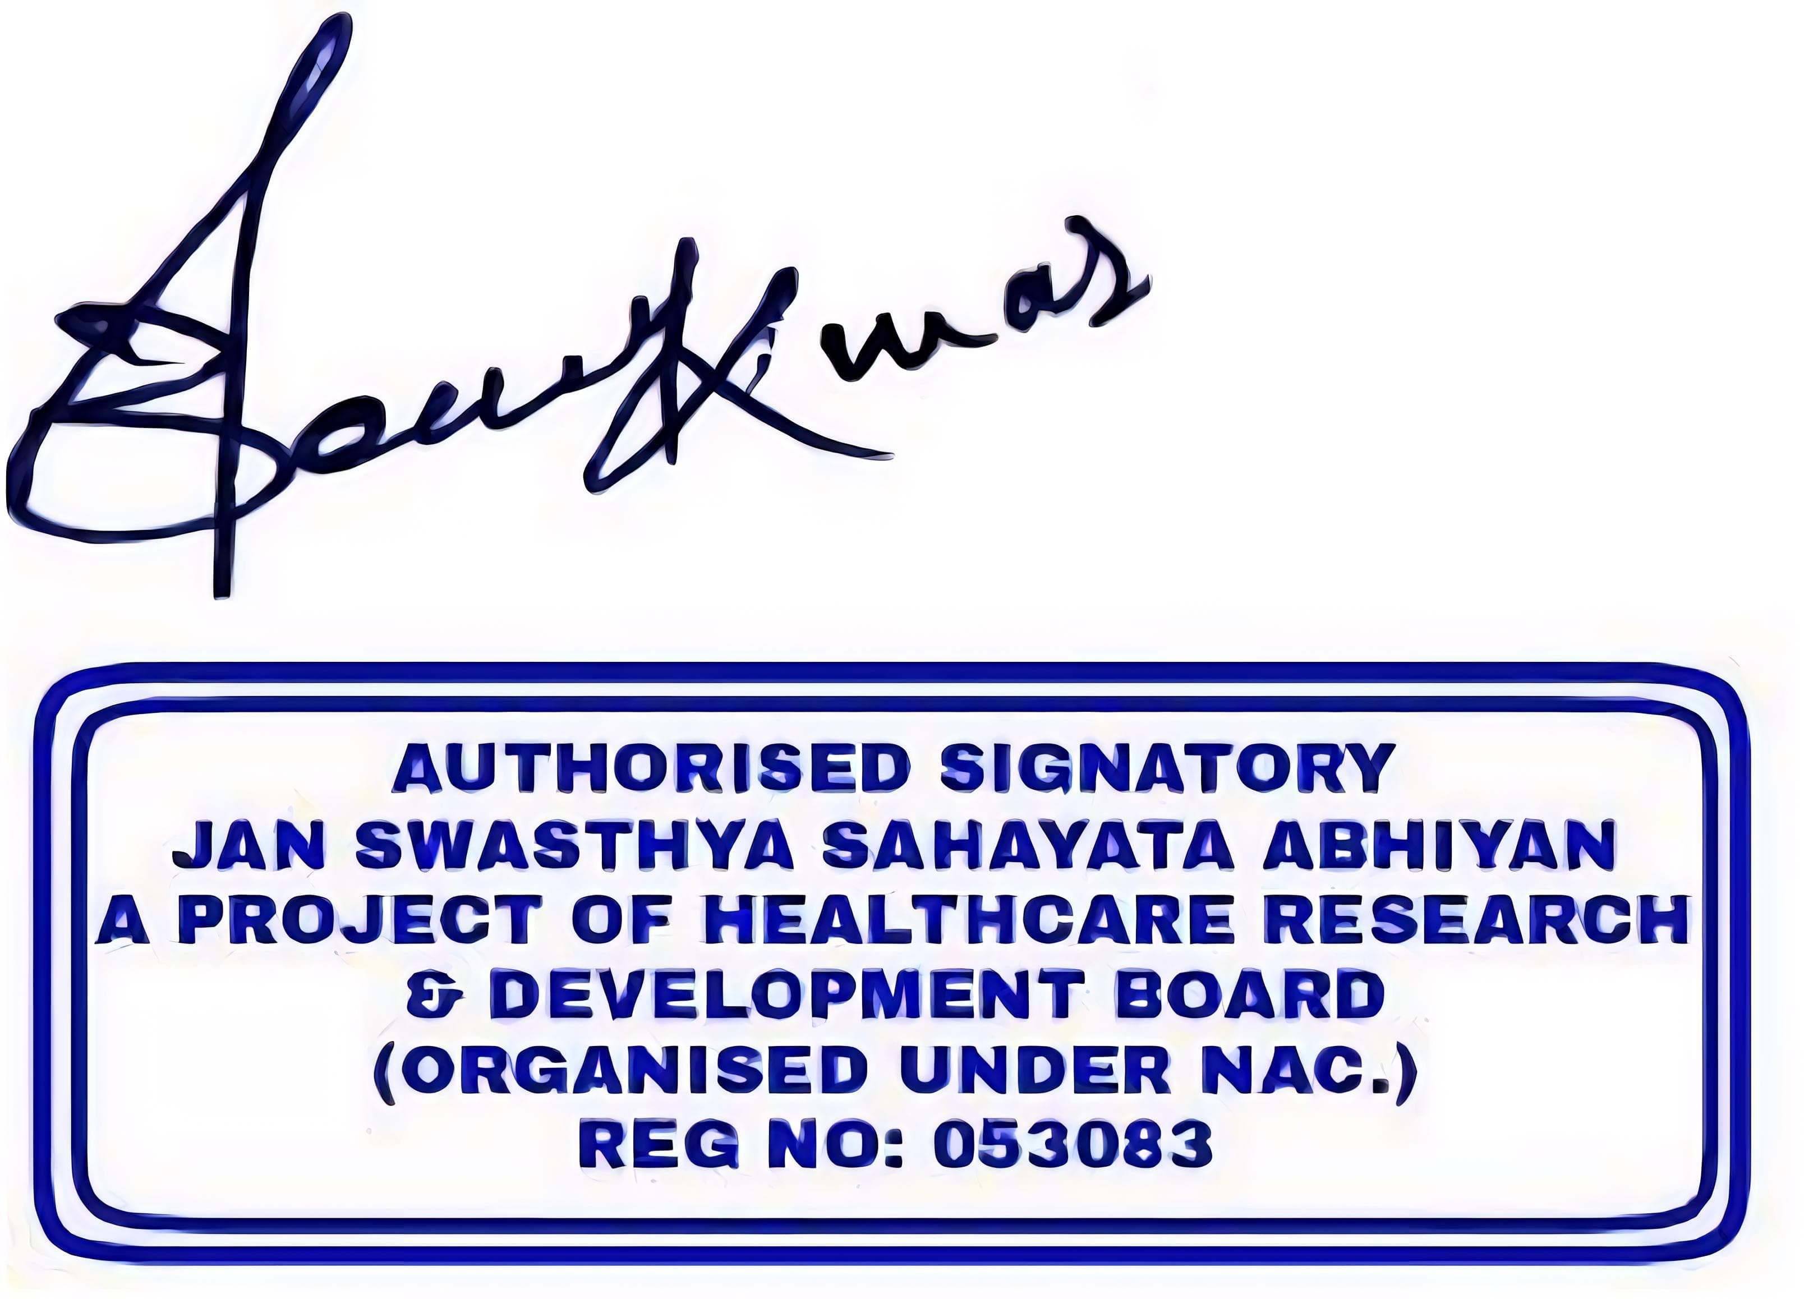

For JAN SWASTHYA SAHAYATA ABHIYAN
DISTRICT EXECUTIVE

HR Department
Date: 11/17/2025 2:19:20 P

JAN SWASTHYA SAHAYATA ABHIYAN
Place: Dausa ( Rajasthan)

A project of Healthcare Research and Development (Organized under NAC RegNo:053083)
Registered under Companies Act 2013 under the provision of section 8

